

* **Group No:** [6]
* **Group name:** Tiger
* **List of Members:** [Mazhar Feizi

HARPREET Singh

Amritpal Singh

Kawalpreet kaur]

* **Topic of the Project:** Sports Club Management System

Project Report: Sports Club Management System



Contents

1. Executive Summary 2

2. Design Analysis Process 3

Brainstorming 3

User Stories 4

Use Cases 4

Use case diagram 5

Actors 6

Functional Requirements 6

Non-functional Requirements 7

3. Entity Relationship Diagram (ERD) 8

5.Table Designs – Data Dictionary 9

5. Contributions 14

6. References 14

# Sports Club Management system project documentation - Toxic KK

# <https://www.google.com/url?sa=i&url=https%3A%2F%2Fin.pinterest.com%2Fpin%2Fsports-club-management-system-project-documentation-in-2023--799951952580884257%2F&psig=AOvVaw173CLEMBnBDeUkQAfWYisg&ust=1726036385802000&source=images&cd=vfe&opi=89978449&ved=0CBQQjRxqFwoTCPC92-Xgt4gDFQAAAAAdAAAAABAE>

# 1. Executive Summary

Sports Club Management System will minimize the theory of the management of players, teams, trainers, tournaments, and games into one package. The system will assist clubs in organizing the management of their operations, proper tracking of information and general activities that include fixing the games, developing registration for players, and handling tournaments.

In sports club management system, our team mainly focus on tournament management because sports club management system is very big topic and tedious to handle so we focus on sub parts.

The key components of this system include: The key components of this system include:  
• Coach and Team Management: It allows coaches to be in charge of their teams, and individual players if need be.  
• Game Scheduling: Deeds; Helps in liaising for games to be played in tournaments.  
• Player and Tournament Information: Contains information about player and tournaments including statistics.

# 2. Design Analysis Process

# Brainstorming

After finalising the topic, we all get numerous ideas and topics which are under the sports club management system. we all distribute the sub-parts and start doing work on it like who are the users and as a user what benefits they actually want from the system, what activities are perform as well as the requirements of the system, merits, demerits and relationships are also included Moreover the important parts are highlighted and work on it as a team.

# User Stories

# As a Coach, I wish to increase my player base so as to maintain the current squad list of my team.

# When playing a game, there are always players who are great in one team and a constraint in the other; thus, as a Coach, I have to be able to transfer players between the teams for better control of the game.

# A Player should be able to access the profile and statistics so as to see how well he/she is performing.

# As a Tournament Organizer, the goal is when I am creating a competition, I should be able to sign up teams so that there is a competition to be held.

# As a Tournament Organizer, there is a need to fix games for tournaments so that the various teams have a view of their game schedules.

# As a Coach, I would like to have control of the number of tournaments that my team participates in since this will be helpful for future matches.

# It is important to be able to manage and modify the sports that the club provides and therefore the following feature is pertinent as an Admin.

# As a Player, I would like to be able to edit my personal information in the system so that it would be correct.

# As a Coach, I need to have a way of handling assignments of my team, so as to enhance efficiency of my team.

# Tournament outcome tracking and monitoring is something that an Admin needs to be able to do.

# As a Player, I would like to provide a proper login and logout of the system and be secure.

# Having a well-coordinated team means managing people, therefore as a Coach I need to be able to see all the players in the team and their information.

# Use Cases

# Add New Player: a. Actor(s): Coach b. Description: A coach recruits a new player into his or her group.

# View Player Profile: a. Actor(s): Player, Coach b. Description: A player or a coach looks at players’ detail.

# Transfer Player Between Teams: a. Actor(s): Coach b. Description: Concisely, a player is moved from one team to the next or in other words a switch.

# Schedule Games: a. Actor(s): Tournament Organizer b. Description: The organiser sets up games for a tournament.

# Register Team for Tournament: a. Actor(s): Admin, Coach b. Description: To enter a new season or the next tournament.

# Manage Tournaments: a. Actor(s): Peer 1, Admin of the Tournament b. Description: Tournament management is done by the tournament organizer which involves creating, modifying and fixing games.

# Login/Logout: a. Actor(s): Player, Coach b. Description: Enables a user to login and/or logout securely.

# Update Player Information: a. Actor(s): Player b. Description: The player changes his/her details in the system

# Use case diagram

# Actors

# • Coach: Controls players and teams, swaps players, and examines profiles of players and teams.

# • Player: Performs update of the profile, the authorization, and check of the personal information section.

# • Tournament Organizer: Plans for games, organizes for tournaments.

# • Admin: Allows system settings to be adjusted; also, user can register teams for tournament.

# Functional and Non-functional Requirements

**Functional requirements**

# It must be possible to enroll and release players to and from their teams through the help of the system.

# It needs to be possible for the players to change their personal information within the system.

# The system must have the capability to schedule games and or tournaments.

# There is a need to incorporate data visibility and manageability to the coaches particularly in relation to the team they are assigned to.

**Non-functional requirements**

1. Performance: The system must incorporate at least 1000 clients at a given time and no movements should be noticeable.
2. Security: Player information must be encrypted.
3. Usability: Still, for all actors, the system should possess a friendly user interface.
4. Availability: The quality of the system must be as follows; In terms of availability, it must be 99.9%.

# 3. Entity Relationship Diagram (ERD)

**Logical ERD:**

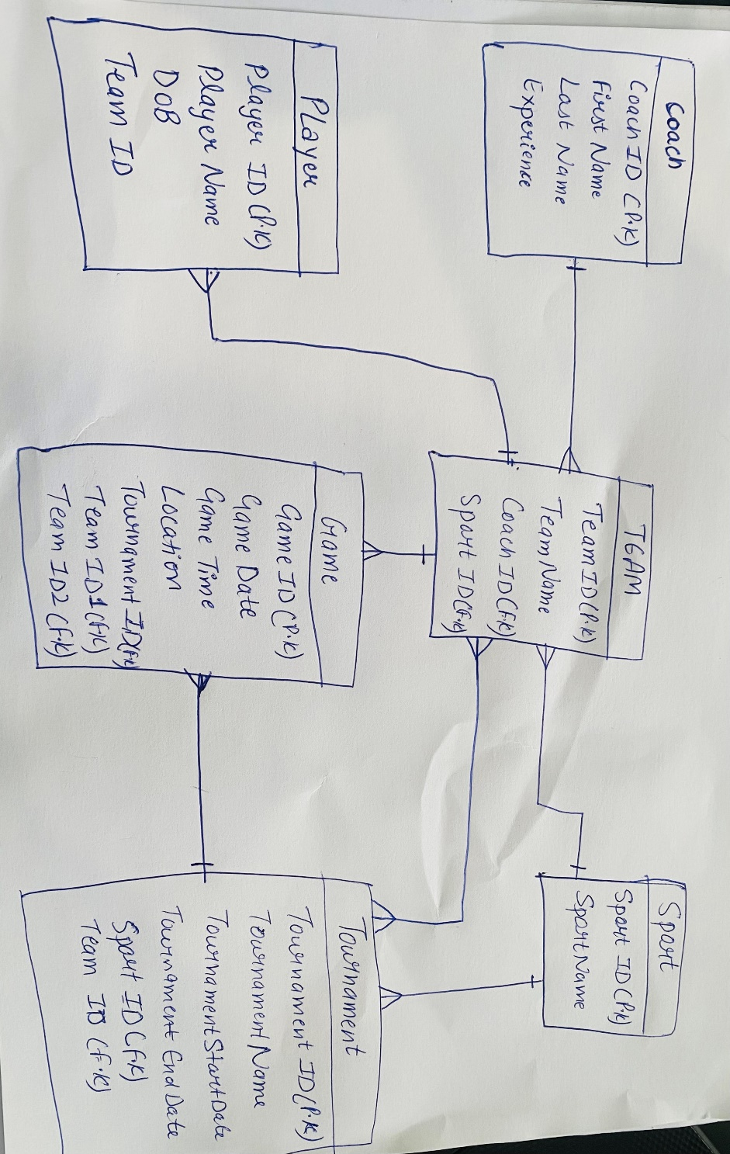

Based on the hand-drawn ERD provided, the logical ERD includes the following entities:

* **Coach**: Linked to Team.
* **Player**: Linked to Team.
* **Team**: Linked to Sport, Coach, Tournament, and Game.
* **Sport**: Linked to Tournament and Team.
* **Game**: Linked to Tournament and two Teams.
* **Tournament**: Linked to Team and Game.

**Physical ERD:**

The physical ERD diagram is updated as per the latest diagram, which includes:

* **Game Table**: Updated with TeamID1 and TeamID2 fields to represent both teams playing in the game.

**Relationships Explanation:**

1. **Coach to Team**: One-to-Many (One coach can manage many teams).
2. **Player to Team**: Many-to-One (Many players belong to one team).
3. **Team to Sport**: Many-o-One (Many teams play one sport).
4. **Team to Game**: Many-to-Many (Each game involves two teams).
5. **Game to Tournament**: Many-to-One (A game is part of one tournament).

# 5.Table Designs – Data Dictionary

1. Coach Table

|  |  |  |  |  |  |
| --- | --- | --- | --- | --- | --- |
| Field Name | Description | Data Type | Key Field | Constraints | Example |
| CoachID | Uniquely identifies each Coach | Auto Number | PK |  | 1 |
| FirstName | The first name of the Coach | Short Text |  |  | john |
| LastName | The last name of the Coach | Short Text |  |  | Doe |
| Experience | Number of years the coach has been coaching | Number |  | Number | 10 |

2. Players Table

|  |  |  |  |  |  |
| --- | --- | --- | --- | --- | --- |
| Field Name | Description | Data Type | Key Field | Constraints | Example |
| PlayerID | Uniquely identifies each Player | Auto Number | PK |  | 1 |
| FirstName | The first name of the player | Short Text |  |  | Alice |
| LastName | The last name of the player | Short Text |  |  | Johnson |
| DOB | The date of birth of the player | Date |  |  | 2001-05-15 |
| Position | The position the player plays | Short Text |  |  | Forward |
| TeamID | The team the player belongs to | Number | FK |  | 1 |

3. Tournament table

|  |  |  |  |  |  |
| --- | --- | --- | --- | --- | --- |
| Entity Name | Entity description |  |  |  |  |
| Tournament | Tournament details |  |  |  |  |
| Field name | Description | Data Type | Key field | Constraints | Example |
| TournamentID | Identifies every tournaments uniquely | Integer | PK |  | 1 |
| TournamentName | Name of tournament | Text |  |  | Summer Cup |
| StartDate | Starting date of tournament | Date |  |  | 2024-09-12 |
| EndDate | Ending date of tournament | Date |  |  | 2024-09-30 |
| SportID | Sport is associated in this tournament , it has relationship | Number | FK |  | 1 |

4.Game table

|  |  |  |  |  |  |
| --- | --- | --- | --- | --- | --- |
| Entity Name | Entity description |  |  |  |  |
| Game | Game details |  |  |  |  |
| Field Name | Description | Data Types | Key Field | Constraints | Example |
| GameID | Uniquely identifies each game | Number | PK |  | 1 |
| GameDate | Date of the game | Date |  |  | 2024-09-14 |
| GameTime | Time of the game | Time |  |  | 2:00 |
| Location | Location of the game | Text |  |  | Stadium |
| TornamentID | Tournament associated with this game | Number | FK |  | 1 |
| TeamID 1 | First team playing | Number | FK |  | 1 |
| TeamID 2 | Second team playing | Number | FK |  | 2 |

5.Sport table

|  |  |  |  |  |  |
| --- | --- | --- | --- | --- | --- |
| Entity Name | Entity Description |  |  |  |  |
| Sport | Sport information |  |  |  |  |
| Field Name | Description | Data type | Key Field | Constraints | Example |
| SportID | Uniquely identifies each Sport | Auto  Number | PK |  | 1 |
| SportName | The name of the Sport | Short text |  |  | Football |

6.Tournament team

|  |  |  |  |  |  |
| --- | --- | --- | --- | --- | --- |
| Entity Name | Entity Description |  |  |  |  |
| Tournament Team | Tournament Team information |  |  |  |  |
| Field Name | Description | Data type | Key Field | Constraints | Example |
| TournamentTeam | Uniquely identifies each record | Auto number | PK |  | 11 |
| TournamentID | The tournament linked to the team | Number | FK |  | 23 |
| TeamID | The team participation in the tournament | Number | FK |  | 12 |

7.Team table

|  |  |  |  |  |  |
| --- | --- | --- | --- | --- | --- |
| Field Name | Description | Data Type | Key Field | Constraints | Example |
| TeamID | Uniquely identifies each team | Auto Number | PK |  | 1 |
| TeamName | The name of the team | Short Text |  |  | Tigers |
| CoachID |  | Number | FK |  | 1 |

# 5. Contributions

* **Mazhar Feizi**: Developed the database schema, including the Entity Relationship Diagram (ERD), and ensured the integration between the database and application logic. Mazhar also handled the data entry and validation processes.
* **Harpreet Singh**: I have done the Sport and Tournament team table. And help in ERD as well as data dictionary. Most of the work regarding our project is done in the classroom together like user stories, use cases, brainstorming, and many more.
* **Kawal Preet**: I ensured the application is user-friendly and responsive, handling interactions for game and tournament table. We also done work together on one laptop in classroom and work on final report.
* **Amritpal Singh**: I have done team table.

**Github link:** [**https://github.com/mazhar1341/TIGER**](https://github.com/mazhar1341/TIGER)

# 6. References